**CCTV Proposal for Bosniak Islamic Center**

**Customer Info:**
Islamic Center of Richmond Hill
Email: nybosniakcenter@gmail.com
Address: 114-7 91st Ave. Queens, NY 11418, Richmond Hill

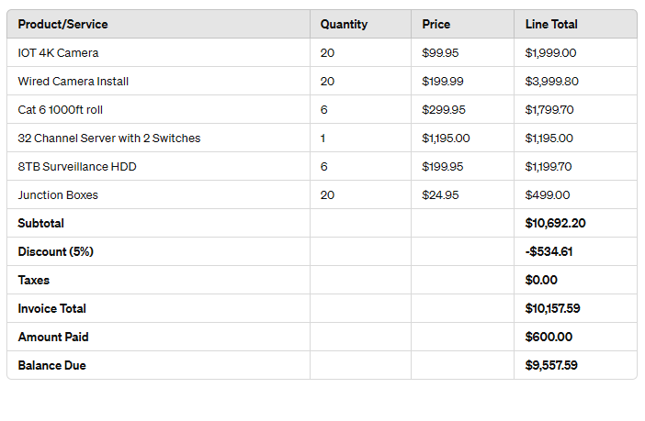
**Project Timeline:**
The project timeline will commence one week after receipt of the deposit. Installation is estimated to take approximately 5-7 business days from the project start date.

**Scope of Work:**

1. **Total Cameras:** 20 cameras will be installed in the Bosniak Islamic Center premises.

2. **Location Details:**
- **Prior Locations (13 cameras):**
- **New Locations (7 cameras):**
- Roof access & staircase
- Women's prayer area
- Basement hallway (x2)
- Gym facing north
- Gym facing south
- Kitchen

3. **Installation Requirements:**
- Cameras will be strategically placed to ensure comprehensive surveillance coverage.
- Wiring and connectivity will be established for optimal camera performance.
- Integration with the 32 Channel Server and switches for centralized monitoring and data storage.
- Junction boxes will be installed as necessary to facilitate camera connections.

4. **Testing and Commissioning:**
- Each camera will undergo testing to ensure proper functionality.
- System integration and networking will be tested to ensure seamless operation.

5. **Training:**
- Basic training will be provided to designated personnel for camera monitoring and system management.

6. **Documentation:**
- Comprehensive documentation including camera locations, wiring diagrams, and system configurations will be provided upon completion.

**Terms and Conditions:**
1. **Access to Property:** The customer must provide unrestricted access to the property for installation purposes.
2. **Safe Working Conditions:** The customer must ensure a safe working environment for our installation team.
3. **Responsive to Onsite Concerns:** The customer agrees to be responsive to any onsite concerns raised during the installation process.
4. **Notice of Schedule Changes:** The customer must provide advance notice of any rescheduling or uncertainties in the schedule or events that may affect the project timeline.
5. **Prompt Payments:** Payments must be made promptly as per the agreed terms.
6. **Deposit Requirement:** A 50% deposit is required to initiate work, with the remaining 50% due upon project completion.

Sincerely,
Ahmed W Elzoghabi
Iot Techs - General Manager
Phone: +1 646-396-0775
Email: support@iot-techs.com
Website: www.iot-techs.com
Address: 120 Industrial Ave #4, Little Ferry, NJ 07643

